Driving a motor… with buttons!

# **Description**

This tutorial is a guide for driving a Vex IQ Smart Motor with the Vex IQ Controller buttons

# **Instructions**

1. Look on the desktop for the Robot C icon. Select the “RobotC for Vex Robotics”  
   Do not open the “Graphical ROBOTC” program  
   1. 
2. Open a new file and enter the following  
   1. 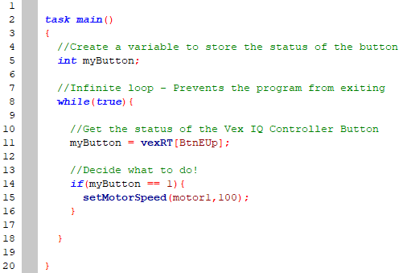
3. Compile, Download to Robot, and Start
   1.  🡪  🡪 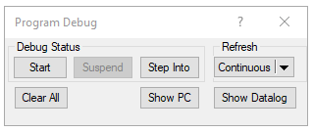
4. Notice, the motor never stops! Why?
5. Let’s try adding an **else statement** to stop the motor when we’re *not* pressing **Button E Up**  
   1. 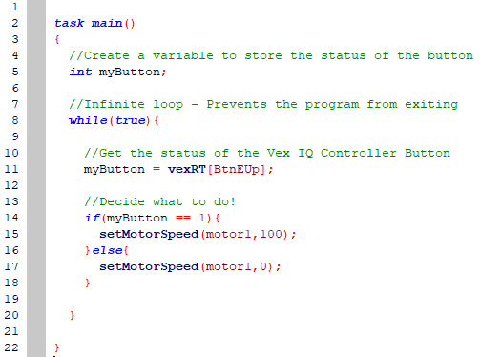
6. Change up the motor and speed!
   1. Try using a different motor port (ex. “motor6” or “motor12”)
   2. Try using a different speed (ex. “-100” or “25”)
7. Add another button to control a different motor!
   1. Add another global variable for a second button
   2. Fill the second variable with another vexRT[] button
   3. Decide which motor to control with the second button
8. Use the following as a guide for changing buttons

